NEW PATIENT APPLICATION

First Name(s): |  |  |  |  |  |  |  |  | Surname:
Date of Birth: |  |  |  |  |  |  | Place of Birth:
Address:
Postcode:
Previous Address, if recently moved;

Phone No: Mobile* |  |  |  |  |  |  |  |  |  |  |  | Home:
*We use mobile telephone numbers provided to send appointment confirmations, and reminder text messages. If you DO NOT wish to receive these free reminders please tick here You can add your consent at any time with reception. If you do tick this box we cannot send you any sms.
Email address:
Dependent children to join? – please add below;

Name: |  |  |  |  |  |  |  |  |  | Relationship: |  |  |  |  |  |  | Age:
Name: |  |  |  |  |  |  |  |  |  | Relationship: |  |  |  |  |  |  | Age:
Name: |  |  |  |  |  |  |  |  |  | Relationship: |  |  |  |  |  |  | Age:
Previous GP/Surgery name:
Main spoken Language:
Interpreter Required? |  |  |  |  |  |  |  |  |  |  | Yes No
Date you first entered the UK?
Do you have any requirements to
help you accessing information?
i.e Braille, EasyRead, Large print etc
For Office use only:
Date form completed |  | List checked |  |  | Accepted? |  |  | Date patient informed |  |  |  |  |  | NPHC appt date |  | Date Scanned
/ / |  | / / |  |  | Y / N |  |  | / / |  |  |  |  |  | / / |  | / /

PTO…

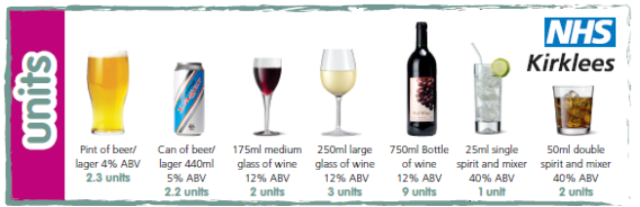

Audit C | Questions |  | Scoring System
Audit C |  |  | 0 | 1 | 2 | 3 | 4
Audit C | 1 | How often do you have a drink that contains alcohol? | Never | Monthly or less | 2-4 times per month | 2-3 times per week | 4+ times per week
Audit C | 2 | How many units do you have on a typical day when you are drinking? (see guide above for units) | 1 - 2 | 3 - 4 | 5 - 6 | 7 - 8 | 10+
Audit C | 3 | How often do you have 6 or more units on one occasion? | Never | Less than monthly | Monthly | Weekly | Daily or almost daily

Score:

Thank you for completing a New Patient Application Form. The Doctor will now check the form and either accept or decline your application. Please call in to the surgery, or telephone 01484 500921, after 2 days to see if your application has been accepted.

You will then be asked to make a New Patient Health Check appointment with the Health Care Assistant. You will not be able to see the GP until you have had this check. Please bring any medication you use and a urine sample (bottles available from reception) to your Health Check appointment.

We only keep these forms for 2 weeks, so if you don’t get back in touch, we assume you have registered elsewhere and will securely destroy your form securely.

If you do not attend your New Patient Health Check Appointment you will not be registered here as a patient. Unfortunately, if you miss your New Patient Health Check appointment, we will not be able to make you a new appointment, experience tells us that if patients fail to attend appointments before they are registered, they continue to miss them once they are patients.

